- The Monetary Policy Committee narrowly voted to cut Bank Rate by 25bps to 4.25% at its meeting this week. The MPC's tone was more hawkish than markets anticipated, but the message was in line with our forecast for two more 25bp cuts in H2 2025. Still, we wouldn't rule out a dovish pivot later this year, particularly if growth and inflation surprise on the downside.
- The UK government announced trade deals with India and the US this week. The former should boost bilateral trade modestly, while the latter saw the US cut car and steel tariffs on UK exports in exchange for lower UK tariffs on imports from the US. These agreements will have important sectoral implications, but the macroeconomic impacts will be small.
The Bank of England's May monetary policy decision was the week's main event. Coming into the May meeting, we regarded a 25bps rate cut as a done deal and were looking for signals about where policy was likely to go from there.
In the event, the MPC narrowly voted 5-4 to cut Bank Rate by 25bps to 4.25%, with the committee struggling to form a consensus amid elevated levels of uncertainty. Swati Dhingra and Alan Taylor voted for a 50bps cut, while Huw Pill and Catherine Mann voted for no change.
Markets had moved to price extra rate cuts in recent weeks. But the MPC's core message was more hawkish than markets had anticipated and in response the two-year gilt yield rose 16bps between 12pm and the market close on Thursday. The hawkish message had three strands.
First, the MPC's growth forecast was relatively strong. Favourable historical revisions and stronger-than-expected growth in Q1 led the BoE to upgrade its forecast modestly for this year. The MPC's 2026 GDP growth forecast was only downgraded by 0.25ppts, with the MPC assuming much of the negative impact of US tariffs would be offset by looser financial conditions and lower oil and fuel prices. This left the BoE's projection well above consensus and our own forecast (Chart 1).
Chart 1: The BoE's made limited downgrades to its growth forecast, which looks too optimistic
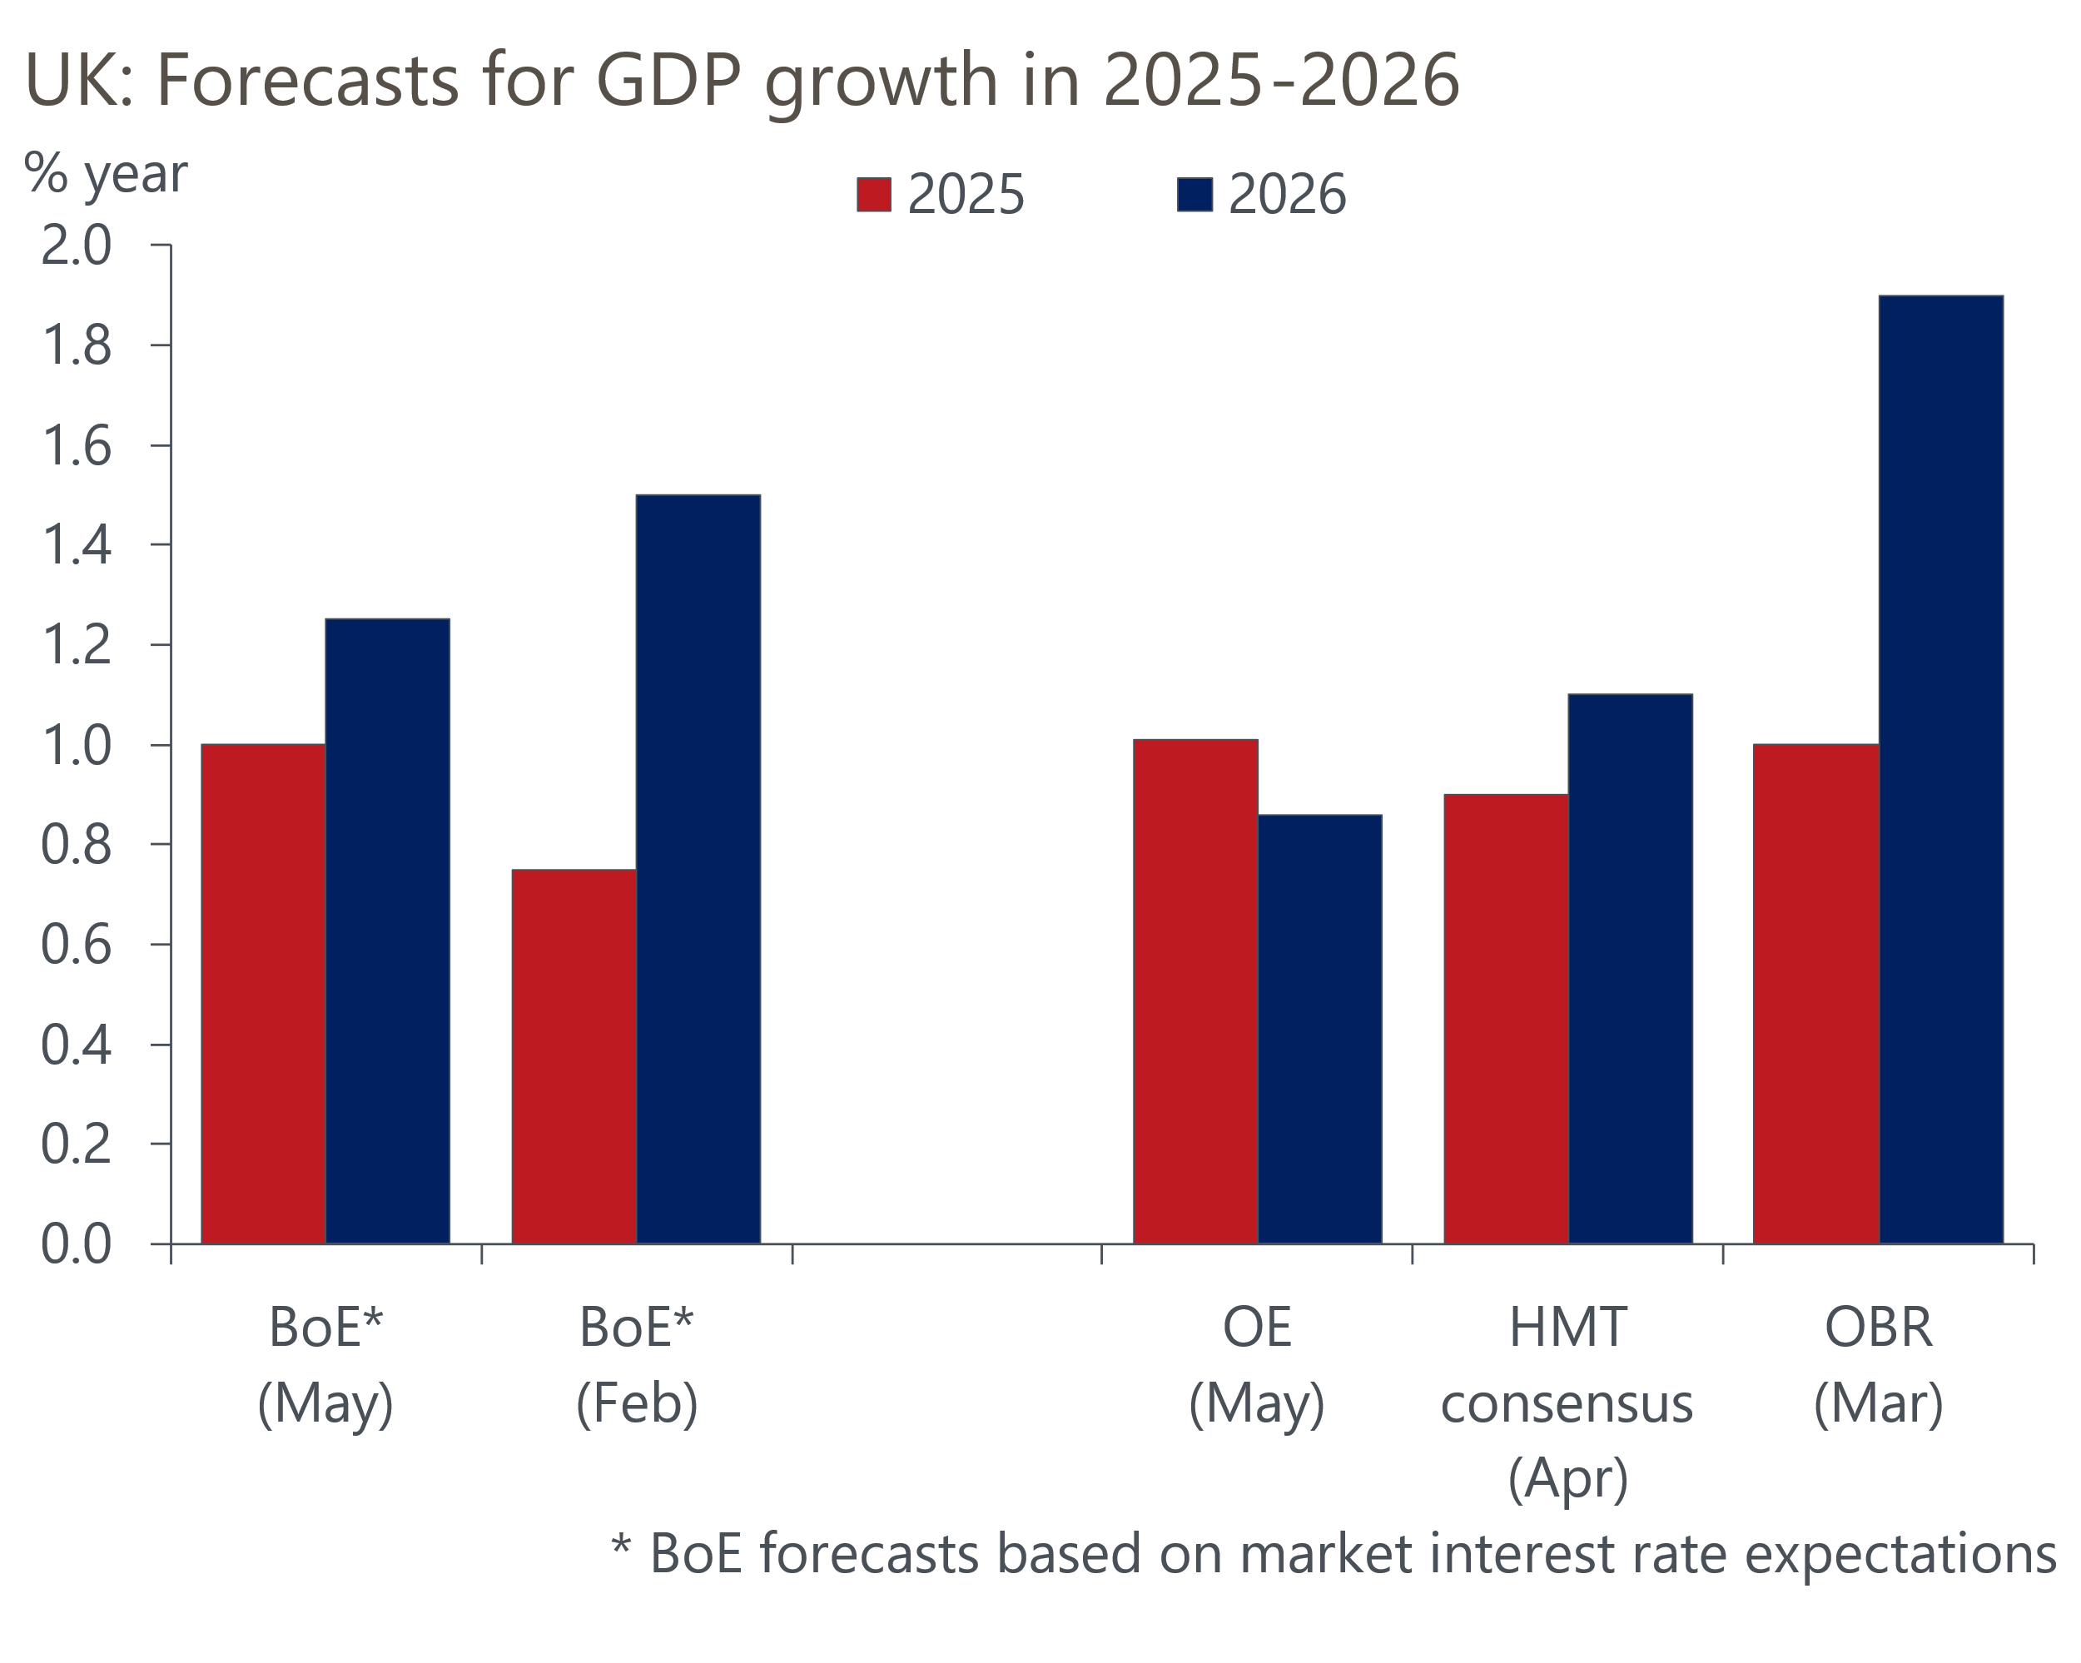
Sources: Oxford Economics, BoE, HMT, OBR

Second, the minutes reported that for most MPC members who voted for a 25bps cut this month, the decision whether to cut or not would have been finely balanced were it not for US tariff announcements. This is the first time the minutes have highlighted that a decision to lower Bank Rate was close during this cutting cycle and this wording suggests the MPC were attempting to set a hawkish tone.
Third, in February Governor Andrew Bailey emphasised the importance of the phrase "gradual and careful", when discussing the MPC's approach to loosening policy. Leaving out either or both words would have signalled the committee were open to stepping up the pace of rate cuts. But the phrase was retained in the minutes of the May meeting, suggesting the chances of a June rate cut are low.
By contrast, the MPC's new inflation forecast was notably less hawkish. The near-term profile was lower, reflecting the strengthening in sterling and falls in oil and gas futures prices since the US tariff announcements. Further out, the MPC expects slightly more slack to emerge than before, despite the forecast being based on a market curve that was nearly 60bps lower than the February forecast in 2026. By projecting inflation will be slightly below the 2% target at the two- and three-year horizon, the committee implicitly endorsed the fall in market interest rate expectations since February.
Overall, the clear pushback against faster rate cuts means we maintain our forecast for two further 25bps cuts in August and November. But our forecast suggests growth and inflation will surprise the MPC on the downside. The committee is yet to form a consensus on how to think about the tariff shock and made repeated references to heightened uncertainty in the minutes. And factoring in the uncertainty around the inflationary impact of April's increases in employers' national insurance contributions and the national living wage, there's potential for significant volatility in the MPC's commentary. We wouldn't rule out the prospect of a sudden dovish pivot later this year.
Separately, this week saw the UK government announce trade deals with India and the US. Though the deals are yet to be formally signed and the final details are still to be agreed, neither is likely to be a game-changer. The UK-India Free Trade Agreement was largely focused on reducing tariffs, with some measures to reduce non-tariff barriers. The UK government's estimates suggest the deal will boost the level of GDP by 0.1% by 2040.
The trade agreement with the US will see US tariffs on British steel and aluminium reduced to zero, while tariffs on automotive exports to the US will fall from 27.5% to 10% for a quota of 100,000 cars. The 10% baseline tariff on other non-exempt UK exports to the US, announced on April 2, will remain in place (Chart 2), while the UK will lower tariffs on imports from the US. The agreement will improve outcomes in the UK steel and automotive sectors. But the agreement covers less than 1% of total UK exports, so will do little to offset the damage to UK growth prospects from the US tariff announcements of the past couple of months.
Chart 2: The UK-US trade agreement leaves 5% of UK exports exposed to the US' 10% baseline tariff
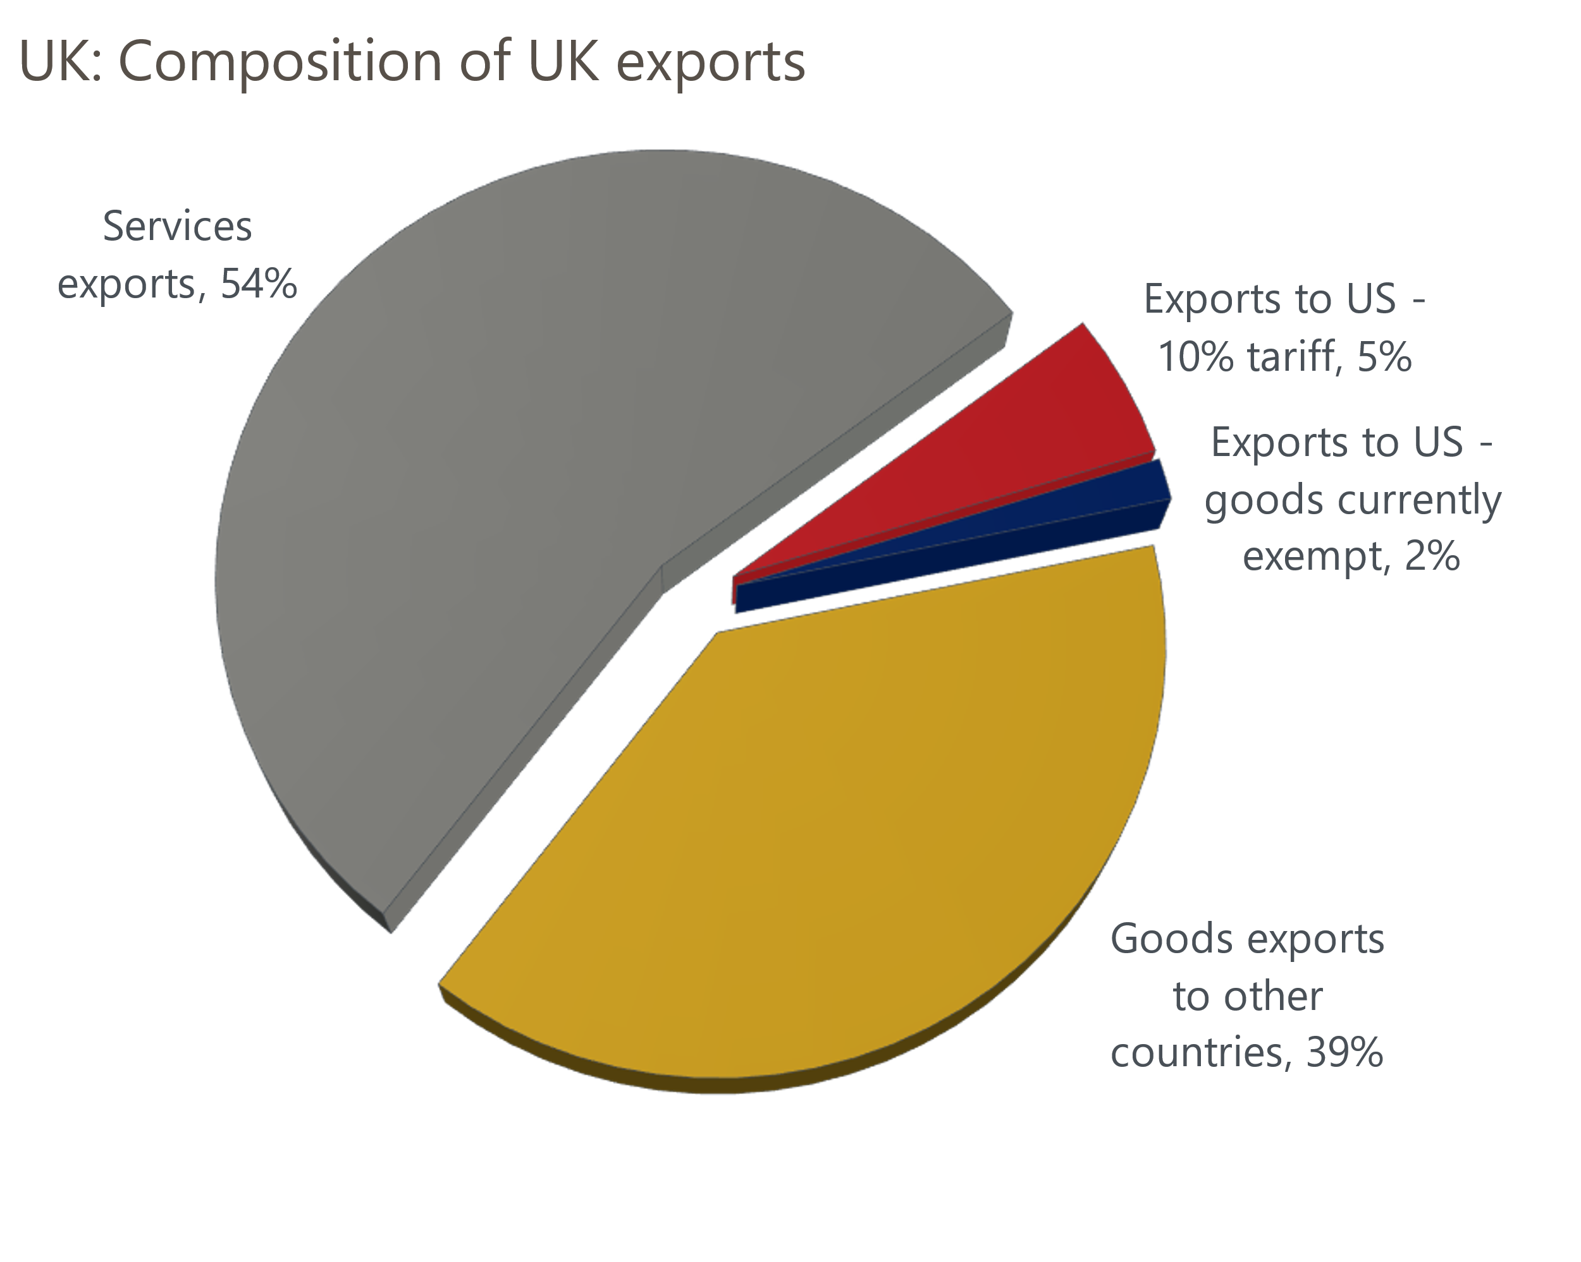
Source: Oxford Economics calculations using data from Haver Analytics

The week ahead
The first of the week's two major economic releases is the labour market data for January-March. Base effects are likely to play a key role in the pay data, given there was a strong pickup in whole economy regular pay growth in March 2024. Furthermore, the large rise in bonus payments that month will also weigh on total pay growth in the three months to March 2025, and this effect will be amplified given the big increase in bonus payments in December 2024 will fall out of the three-month average. Therefore, we forecast total pay growth will slow to 5.2%, while regular pay growth is expected to fall to 5.6% in the three months to March.
On the quantities side, we think the unemployment rate ticked up to 4.5% in the three months to March. This is due to December's low single-month reading dropping out of the three-month average. But with the Office for National Statistics yet to introduce key methodological changes to its flagship Labour Force Survey, we continue to see the LFS data as an unreliable indicator of conditions in the job market.
Next week will also see the release of GDP data for March. Activity rose very sharply in February, propelled by some unusually strong outturns at the sectoral level – particularly in the manufacturing, utilities, distribution, communications, and administrative services sectors. We think there will be some payback in these sectors, so estimate that GDP fell by 0.3% m/m in March.
Table 1: Week ahead calendar
Date | Events | Period | Measure | Unit | Previous | Forecast
May 13 | LFS unemployment | Jan-Mar | Rate | % | 4.4 | 4.5
May 13 | Average earnings (total pay) | Mar | 3m, y/y | % | 5.6 | 5.2
May 13 | Average earnings (regular pay) | Mar | 3m, y/y | % | 5.9 | 5.6
May 15 | GDP | Mar | m/m | % | 0.5 | -0.3
May 15 | GDP | Mar | 3m/3m | % | 0.6 | 0.6
May 15 | Index of services | Mar | m/m | % | 0.3 | -0.2
May 15 | Index of services | Mar | 3m/3m | % | 0.7 | 0.6
May 15 | Manufacturing output | Mar | m/m | % | 2.2 | -1.6
May 15 | Manufacturing output | Mar | y/y | % | 0.3 | -1.7
May 15 | Industrial production | Mar | m/m | % | 1.5 | -1.2
May 15 | Industrial production | Mar | y/y | % | 0.1 | -1.4
May 15 | Construction output | Mar | m/m | % | 0.4 | 0.2
May 15 | Construction output | Mar | y/y | % | 1.6 | 1.3
May 15 | UK trade | Mar | Trade balance | £bn | -2.0 | -2.5
May 15 | UK trade | Mar | Visible balance | £bn | -20.8 | -21.5
Source: Oxford Economics

Key forecasts
Table 2: UK forecast overview
(Annual percentage changes unless specified)
 | 2022 | 2023 | 2024 | 2025 | 2026 | 2027
GDP | 4.8 | 0.4 | 1.1 | 1.0 | 0.9 | 1.3
Private consumption | 7.3 | 0.5 | 0.6 | 1.2 | 1.1 | 1.2
Fixed investment | 5.1 | 0.3 | 1.5 | 1.0 | 1.0 | 1.6
Government consumption | 0.6 | 1.6 | 3.0 | 2.3 | 1.2 | 1.5
Exports of goods and services | 12.6 | -0.4 | -1.2 | 1.0 | -1.5 | 1.2
Imports of goods and services | 13.0 | -1.2 | 2.7 | 0.8 | -0.4 | 1.1
Industrial Production | -6.4 | -0.8 | -1.2 | -0.2 | -0.3 | 0.7
Consumer prices | 9.1 | 7.3 | 2.5 | 3.0 | 2.4 | 2.3
Unemployment rate (%) | 3.8 | 4.1 | 4.3 | 4.6 | 4.9 | 4.8
Current a/c balance (% of GDP) | -2.2 | -3.5 | -2.7 | -2.6 | -2.9 | -2.7
Government balance (% of GDP) | 4.3 | 5.2 | 5.1 | 4.4 | 3.6 | 2.9
Central bank policy rate (%, EOP) | 3.50 | 5.25 | 4.75 | 3.75 | 3.00 | 2.50
10yr govt. bond yield (%, EOP) | 3.67 | 3.54 | 4.57 | 4.34 | 3.87 | 3.44
Exchange rate (US$ per £, EOP) | 1.20 | 1.27 | 1.25 | 1.32 | 1.32 | 1.32
Exchange rate (euro per £, EOP) | 1.13 | 1.15 | 1.21 | 1.17 | 1.17 | 1.17
Source: Oxford Economics
Table 3: Quarterly forecasts for the UK
 | 2025 |  |  |  | 2026
 | Q1 | Q2 | Q3 | Q4 | Q1 | Q2 | Q3 | Q4
GDP (% year) | 1.1 | 0.9 | 1.0 | 1.1 | 0.7 | 0.8 | 0.9 | 1.0
CPI inflation (% year) | 2.8 | 3.1 | 3.3 | 2.9 | 2.7 | 2.1 | 2.3 | 2.4
Bank Rate (%, EOP) | 4.50 | 4.25 | 4.00 | 3.75 | 3.50 | 3.25 | 3.25 | 3.00
10yr gilt yield (%, EOP) | 4.70 | 4.50 | 4.42 | 4.34 | 4.22 | 4.09 | 3.97 | 3.87
US$ per £ (EOP) | 1.29 | 1.32 | 1.32 | 1.32 | 1.32 | 1.32 | 1.32 | 1.32
Euro per £ (EOP) | 1.20 | 1.17 | 1.17 | 1.17 | 1.17 | 1.17 | 1.17 | 1.17
Source: Oxford Economics

Latest Country Economic Forecast:
April 16, 2025

Recent publications

Data Insights
Tariff announcements hit sentiment in the services sector
Stamp duty changes dominate mortgage data
Difficult outlook for the manufacturing sector
Retail's strong start to 2025 may not last
April's flash PMIs plunged amid elevated trade uncertainty

Research Briefings
MPC stays on its "gradual and careful" path
MPC Preview – tariffs could prompt a less cautious approach
How will central banks react to the trade war?
Higher tariffs damage growth prospects
Trump tariffs will cut UK growth as global demand weakens

Contacts

Oxford Economics' UK team
- Andrew Goodwin - Chief UK Economist - agoodwin@oxfordeconomics.com
- Edward Allenby - UK Economist - eallenby@oxfordeconomics.com

